**Parthenon**

*Athens, Greece*

The Parthenon is a marble temple build in 5th century B.C. during the rise of the ancient Greek empire. It has endured fires, explosions, earthquakes and looting but remains, although in battered condition, a symbol of ancient Greece and Athenian culture. The temple still sits atop the Acropolis of Athens.

The Parthenon has a rectangular floor plan and is built on a 23,000 square foot base. There are small steps that surround the entire building. At the perched top, there are 46 columns surrounding the inside of the building. Each column is slightly tapered, and the corner columns are slightly larger.

From 3D printing restrictions, some parts of the Parthenon needed to be simplified. The columns were the largest change. Each column was made with a spiraled taper. This needed to be simplified to just taper as the column meets the roof.

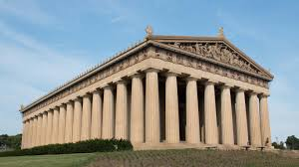

Figure 1- Digital picture of the Parthenon before a battered future of wars and natural events.

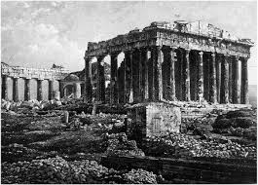

Figure - The Parthenon photographed in 1839, the earliest known photograph of the building.